**Master Functional Document**

|  |  |
| --- | --- |
| **Application** | NGERP - Centra |
| **Service Bundle** | Master Management |
| **Service Request** | Schedule |

**Description :**

Schedulemaster is used to schedule the running time of the DB jobs.

**Workflow Process :**

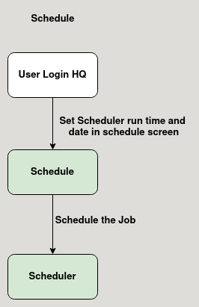

**Business Rules :**

* Schedule master is only editable in HQ.
* User can use this master to schedule the Database Jobs.
* User can choose the frequency, day and time to schedule the Job.
* This master is mapped to a scheduler.